Page URL: **/content/en/us/products/servers-unified-computing/index**

5

4

1

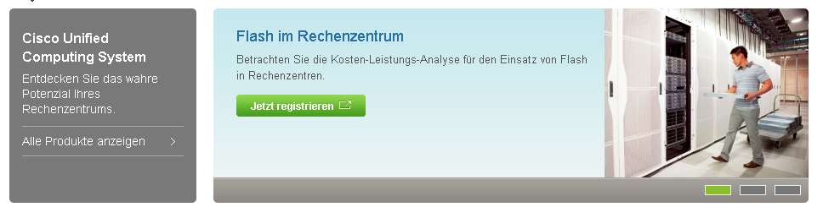

6

3

2

10

7

8

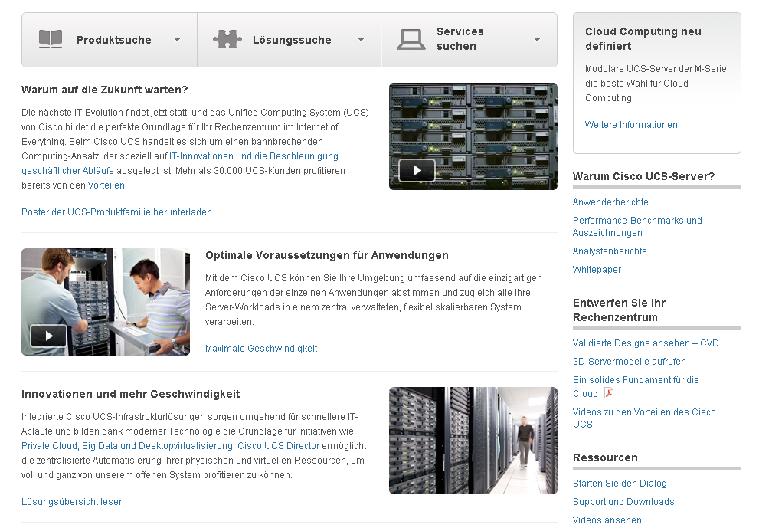

14

13

12

11

9

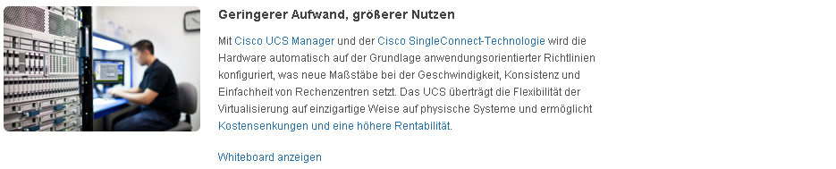



15

|  |  |  |
| --- | --- | --- |
| 1 | /content/en/us/products/servers-unified-computing/index/jcr:content/content_parsys/overview/layout-overview/gd12v1/gd12v1-left/primary_cta_v2/title | Select(“div.gd-left”).select("div. c47-pilot").getElementsByTag("h3") |
| 2 | /content/en/us/products/servers-unified-computing/index/jcr:content/content_parsys/overview/layout-overview/gd12v1/gd12v1-left/primary_cta_v2/description | Select(“div.gd-left”).select("div.c47-pilot").getElementsByTag("p") |
| 3 | /content/en/us/products/servers-unified-computing/index/jcr:content/content_parsys/overview/layout-overview/gd12v1/gd12v1-left/primary_cta_v2/linktext  /content/en/us/products/servers-unified-computing/index/jcr:content/content_parsys/overview/layout-overview/gd12v1/gd12v1-left/primary_cta_v2/linkurl/url | Select(“div.gd-left”).select("div.c47-pilot").getElementsByTag("a")  Select(“div.gd-left”).select("div.c47-pilot").getElementsByTag("a").attr(“href”) |
| 4 | /content/en/us/products/servers-unified-computing/index/jcr:content/content_parsys/overview/layout-overview/gd12v1/gd12v1-right/hero_large/heropanel*/title | Select(“div.gd-right”).Select(“div.c50-text”).getElementsByTag(“h2”) |
| 5 | /content/en/us/products/servers-unified-computing/index/jcr:content/content_parsys/overview/layout-overview/gd12v1/gd12v1-right/hero_large/heropanel*/description | Select(“div.gd-right”).Select(“div.c50-text”).getElementsByTag(“p”) |
| 6 | /content/en/us/products/servers-unified-computing/index/jcr:content/content_parsys/overview/layout-overview/gd12v1/gd12v1-right/hero_large/heropanel*/linktext  /content/en/us/products/servers-unified-computing/index/jcr:content/content_parsys/overview/layout-overview/gd12v1/gd12v1-right/hero_large/heropanel*/linkurl | Select(“div.gd-right”).Select(“div.c50-text”).getElementByTag(“p”).getElementsByTag(“b”)  Select(“div.gd-right”).Select(“div.c50-text”).getElementByTag(“p”).getElementsByTag(“a”) .attr(“href”) |
| 7 | /content/en/us/products/servers-unified-computing/index/jcr:content/content_parsys/overview/layout-overview/gd12v2/gd12v2-left/selectorbarlarge/selectorbarpanel*/title  /content/en/us/products/servers-unified-computing/index/jcr:content/content_parsys/overview/layout-overview/gd12v2/gd12v2-left/selectorbarlarge/selectorbarpanel*/titleurl | Select(“div.title”).  getElementByTag(“a”)  Select(“div.title”).  getElementByTag(“a”).attr(“href”) |
| 8 | /content/en/us/products/servers-unified-computing/index/jcr:content/content_parsys/overview/layout-overview/gd12v2/gd12v2-left/selectorbarlarge/selectorbarpanel*/icon | Select(“div.title”).  getElementByTag(“span”) |
| 9 | /content/en/us/products/servers-unified-computing/index/jcr:content/content_parsys/overview/layout-overview/gd12v2/gd12v2-left/htmlblob/html | Select(“div.htmlblob section”) |
| 10 | /content/en/us/products/servers-unified-computing/index/jcr:content/content_parsys/overview/layout-overview/gd12v2/gd12v2-right/tile_bordered*/title | Select(“div.c23-pilot”).getElementByTag(“h2”) |
| 11 | /content/en/us/products/servers-unified-computing/index/jcr:content/content_parsys/overview/layout-overview/gd12v2/gd12v2-right/tile_bordered*/description | Select(“div.c23-pilot”).getElementByTag(“p”) |
| 12 | /content/en/us/products/servers-unified-computing/index/jcr:content/content_parsys/overview/layout-overview/gd12v2/gd12v2-right/tile_bordered*/linktext  /content/en/us/products/servers-unified-computing/index/jcr:content/content_parsys/overview/layout-overview/gd12v2/gd12v2-right/tile_bordered*/linkurl | Select(“div.c23-pilot”).getElementByTag(“a”)  Select(“div.c23-pilot”).getElementByTag(“a”).attr(“href”) |
| 13 | /content/en/us/products/servers-unified-computing/index/jcr:content/content_parsys/overview/layout-overview/gd12v2/gd12v2-right/list*/title | Select(“div.n13-pilot”).getElementByTag(“h2”) |
| 14 | /content/en/us/products/servers-unified-computing/index/jcr:content/content_parsys/overview/layout-overview/gd12v2/gd12v2-right/list/element_list*/listitems | Select(“div.n13-pilot”).getElementByTag(“ul”) |
| 15 | /content/en/us/products/servers-unified-computing/index/jcr:content/content_parsys/overview/layout-overview/gd12v2/gd12v2-left/text/text | Select(“div. c00v0-pilot”).getElementByTag(“p”) |